
Welcome to Mt Si Lutheran!
It is a joy to worship with you today…
In the shadow of Mount Si sits a small country church, wonderfully illuminated by the light of God. We are the church that shares a living, daring confidence in God's grace. Liberated by our faith, we embrace you as a whole person with all your complexities, gifts, questions, and challenges. Join us as we do God's work in Christ's name for the life of the world. We believe our mission is to serve, reach out and grow in grace. ALL are welcome to join us in this quest.
If you are a first-time guest, a member, or a regular attendee, we are glad you are here!
Guests are encouraged to fill in a welcome card located in the entry to the Sanctuary or pew racks so we can keep in touch or answer any questions you might have. Please place cards in the offering plate or hand them to an usher.
The Lil’ Mount Si Wiggle Room is located at the back of the sanctuary. We welcome all children into our wiggle room. We ask that a parent or designated friend or family member stay with the child/children. There are speakers so you can continue to participate in worship.
Pick up a Rainbow Bag for your child (ages 1-5) in the Narthex on the way into worship. The bags are filled with quiet activities for your child during church service.
If you would like additional information on our programs and ministries, you will find our monthly newsletter and brochures available in the narthex as you enter the building. We are glad to share more information and help you find a place which fits your gifts and affinities in God’s ministries here at Mt. Si—or, possibly, your passions will help begin an entirely new ministry at Mt. Si.

During our worship this morning you are welcome to participate in the liturgy by reading the parts in bold and singing along to the music as you feel comfortable. Headings with a * indicate a portion where you are invited to stand as you feel comfortable. The Lord’s Supper is open to all as Christ is the one who sets the table and extends the invitation.
It is wonderful to worship with you today!

GATHERING
Welcome & Announcements
*Gathering Song see screen
*Prayer of Confession & Thanksgiving see screen
We take a moment to reflect on the past days and name in our hearts when we are aware we caused harm to ourselves or others and to acknowledge when we may have caused harm and are not aware. We hear God’s promise to us, “You are forgiven!” and trust that it is true. Thanks be to God!
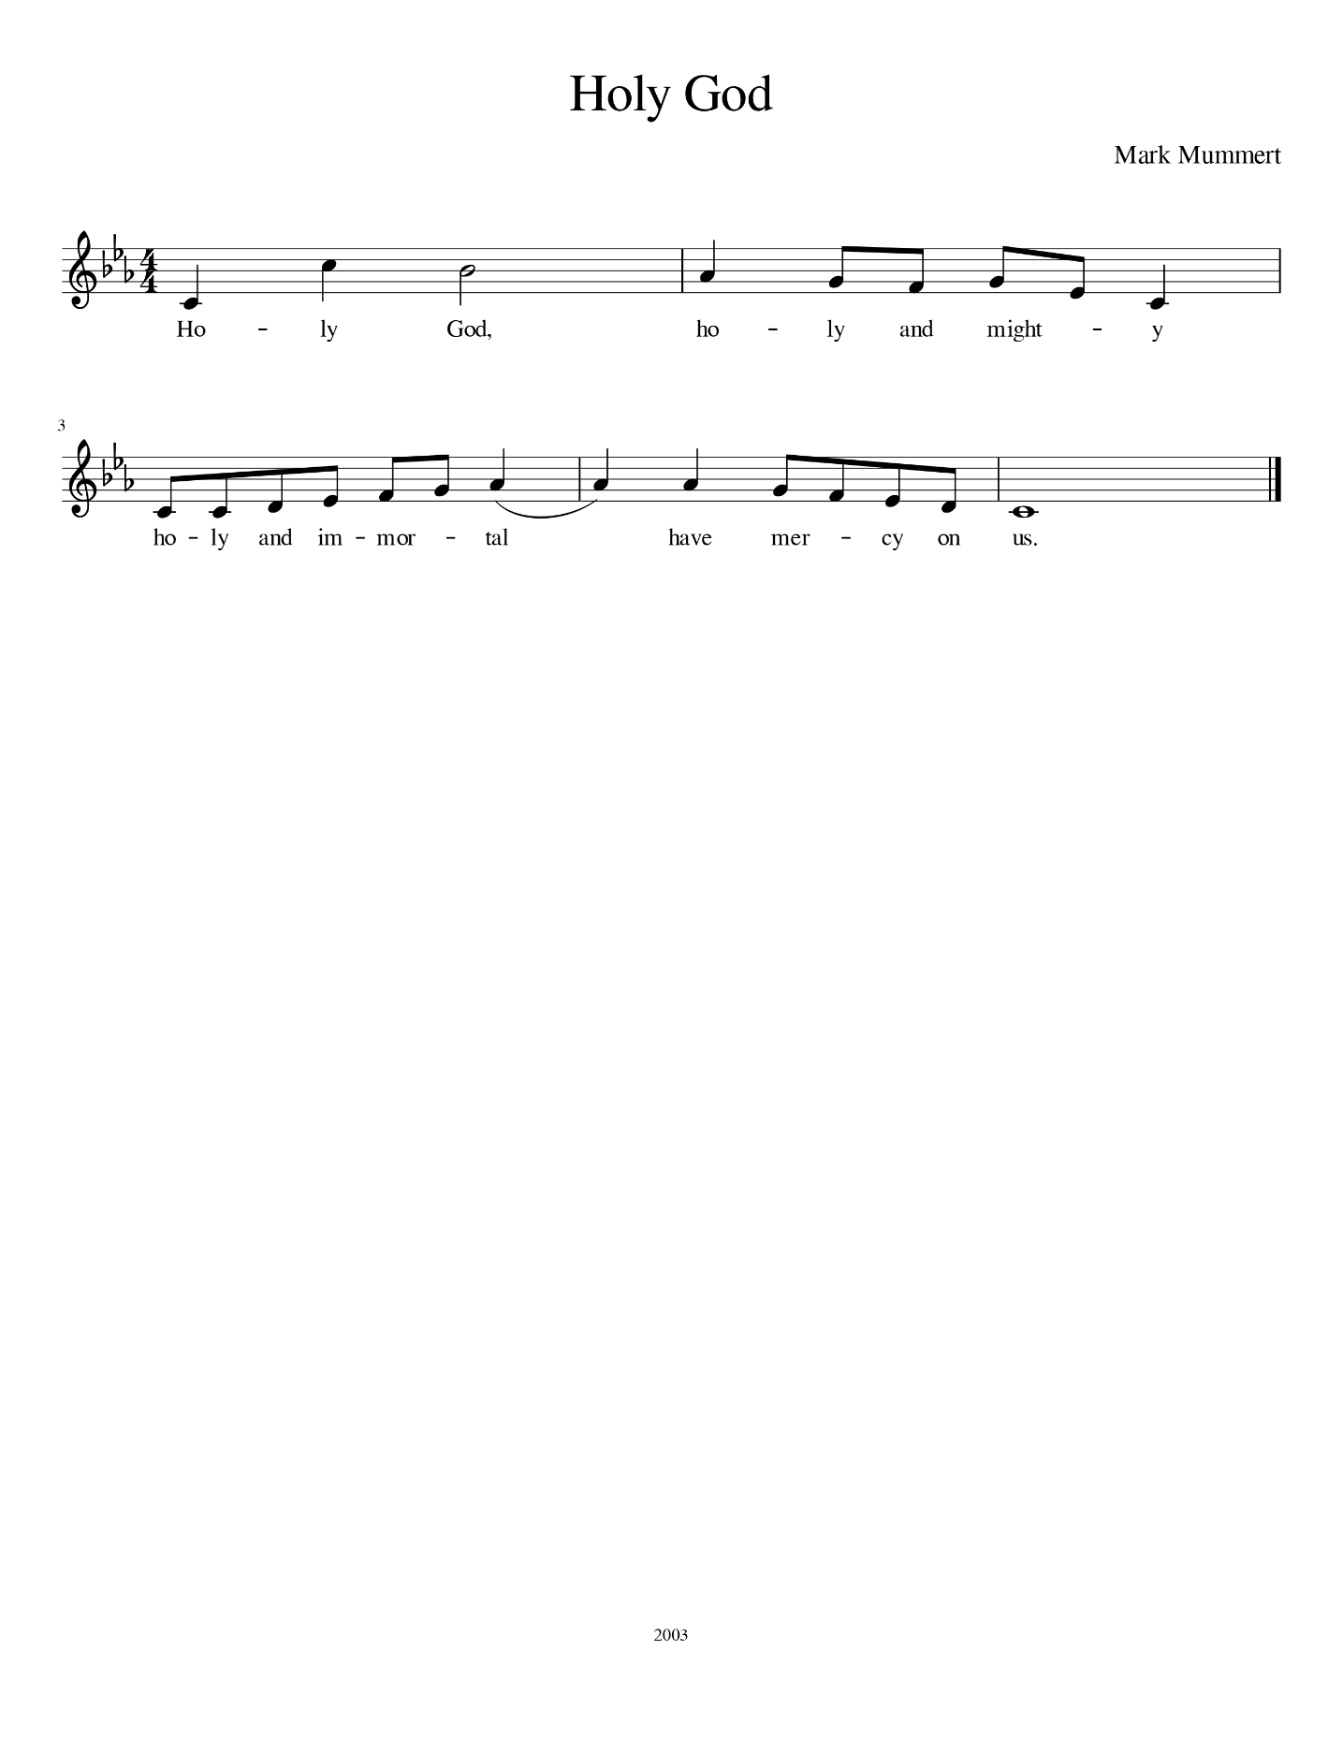
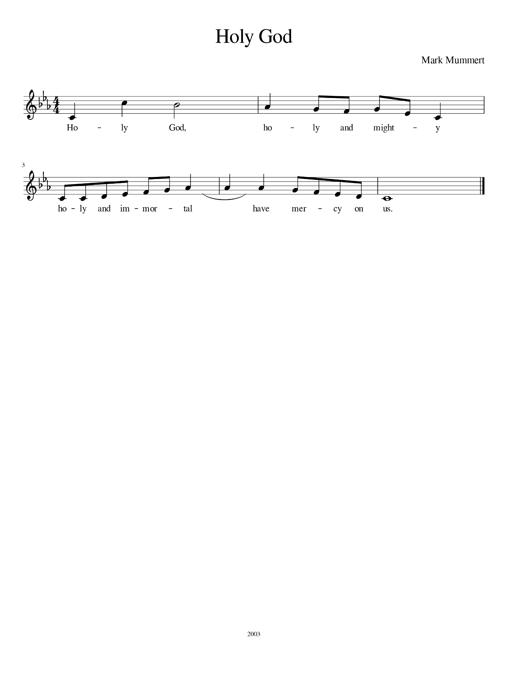
At certain points during the confession, you are invited to sing the following refrain
Red Hymnal #161

HEARING THE WORD
Prayer of the Day see insert/screen
First Lesson see screen
*Gospel Acclamation Setting 1, Red Hymnal pg. 103
We sing a Gospel Acclamation to show our respect and reverence for the Word of God
*Gospel Lesson see screen
Sermon Pastor
*Hymn of the Day see screen

RESPONDING TO GOD’S WORD
Creed see screen
We take a moment to collectively confess our faith as an expressing of unity
Prayers of the People see screen
We offer to God the prayers on our hearts, trusting that God will listen and respond
Peace see screen
We share the peace with one another as an act of building community.
This is a time to remember that we are all children of God.
Offering see screen
Offering Prayer see screen
We offer to God what was first given to us – all our time, talent and possessions. In this space we give thanks by offering monetary gifts for the building up of the Kingdom of God through the ministry of this church. Offering plates were at the back of the sanctuary as you entered and will be there as you leave. You are welcome to make an online donation online: mtsilutheran.org/onlinegiving. Thank you for your generosity!

RECEIVING THE GIFT OF A MEAL
*Communion see screen
The Great Thanksgiving sung ELW Setting III
Preface sung ELW Setting III
Holy, Holy sung ELW Setting III
Words of Institution spoken
Lord’s Prayer spoken Bless This Night

Communion Distribution
Here at Mt Si we believe that Christ is truly present in the bread and wine made holy. We also believe that this is Christ’s table and all are invited. No matter where you find yourself in your journey of faith, you are welcome at this table.
Communion Songs
Lamb of God sung ACS Setting XII

SENDING

*Blessing see screen
*Sending Song see screen
*Dismissal see screen

It was a joy to worship with you today! Please come for Fellowship Hour in the building next door on the main level. Enjoy coffee, tea, snacks and great conversation.

